Software Design Specification (SDS)

Agile System Design & Implementation Readiness Document
Course: PRJ566
Status: FINAL LOCKED VERSION – S26 | Version: v1.0 | Last Updated: 2026-05-03

Section: NCC
Project Title: Smart Spend
Team Number: 03
Team Members: Tina Srivastava, Ananeya Devarasan, Zena Mohamed
Instructor / Faculty Reviewer: Behshid Behkamal
Date: 2026-05-26
GITHUB Link: https://github.com/tinatintina/PRJ566-Group3

Executive Summary
Background
Students often struggle to manage personal finances due to limited financial literacy, irregular income, and lack of simple budgeting tools designed specifically for students. Existing financial applications are often too complex or targeted toward working professionals instead of student lifestyles.
Description
The Student Smart Finance & Expense Management System is a web-based application that allows students to track income and expenses, create monthly budgets, categorize transactions, and visualize spending patterns using dashboards and reports.
Company Value Add
The system demonstrates practical software engineering concepts including full-stack development, database management, authentication, responsive UI/UX design, and Agile project planning. It also provides experience in developing a real-world business application.
End-User Value Add
The platform helps students:
- improve financial awareness
- reduce overspending
- build budgeting habits
- manage monthly expenses more effectively
- visualize spending trends through reports and dashboards
Scope
What is Included:
- User registration and login
- Income and expense tracking
- Transaction categorization
- Monthly budgeting
- Dashboards and reporting
- Responsive web interface
- Relational database integration
What is Not Included:
- Online banking integration
- Investment management
- Cryptocurrency tracking
- Tax filing
- Financial advisor integration
Justification
This project is suitable as a two-semester software engineering project because it involves frontend development, backend programming, database management, authentication/security, UI/UX design, reporting systems, and Agile planning.

Table of Contents
Executive Summary
1. Introduction (Week 1-2)
1.1 Document Authors
1.2 Document Revision History
1.3 Document Purpose
1.4 Audience
1.5 Group Agreement
1.6 File Naming Convention (Required)
2. Project Proposal & Scope (Week 2 / Sprint 1)
2.1 Project Background
2.2 Problem Statement
2.3 Product Vision
2.4 Stakeholders and Users
2.5 Project Scope
2.6 System Risks
2.7 Operating Environment
3. System Behavior & Scenarios (Sprint 1-2)
3.1 Preliminary Product Backlog
3.2 Functional Requirements
3.3 Non-Functional Requirements
3.4 Data Flow Diagrams (DFDs)
3.5 Business Rules
3.6 Refined User Stories and Use Case Scenarios
3.7 Scenario Flows & UI Mapping
4. Sprint 3 Design Artifacts
4.1 UI/UX Design & Prototype
4.2 Domain Model
5. Data Design (Sprint 3)
5.1 RDBMS Design: ERD
5.2 RDBMS Design: Data Dictionary
5.3 NoSQL Design Option
6. Agile Planning Overview (Sprint 4)
6.1 System Setup & Environment Readiness
6.2 GitHub & Project Setup
6.3 Vertical Slice Planning
7. Product Backlog & Sprint Readiness (Sprint 4)
7.1 Product Backlog
7.2 Sprint 1 Candidates
8. Client / Faculty Sign-off

1. Introduction (Week 1-2)

1.1 Document Authors
Name | Role / Responsibility | Email
Ananeya Devarasan | Documentation / Frontend Support | adevarasan@myseneca.ca
Tina Srivastava | Scrum Master / Planning | tsrivastava5@myseneca.ca
Zena Mohamed | Backend / Database Support | zmohamed24@myseneca.ca

1.2 Document Revision History
Week / Sprint | Date | Revisions Made
Week 2 | 2026-05-14 | Added approved business proposal and project scope
Sprint 1 | 2026-05-24 | Added stakeholders, risks, operating environment, and initial system requirements

1.3 Document Purpose
This document defines the Software Design Specification (SDS) for the Student Smart Finance & Expense Management System using an Agile software development approach. The document includes project scope, system requirements, user scenarios, business rules, data design, UI/UX planning, and implementation readiness artifacts for PRJ566 and PRJ666.

1.4 Audience
The intended audience for this document includes:
- Faculty reviewers and instructors
- Project team members
- Future PRJ666 developers
- Stakeholders and evaluators
- Users involved in system testing and feedback

1.5 Group Agreement
This section defines the team’s working agreement, responsibilities, communication expectations, and overall commitment throughout PRJ566 and PRJ666.
Team Overview
Item | Team Response
Team Number | Team 03
Project Title | Student Smart Finance & Expense Management System
Project Time Frame | PRJ566 (Planning & Design) to PRJ666 (Implementation)

Team Members
Name | Student ID | Email | Signature
Ananeya Devarasan | 171549231 | adevarasan@myseneca.ca | Ananeya Devarasan
Tina Srivastava | 103297230 | tsrivastava5@myseneca.ca | Tina Srivastava
Zena Mohamed |  | zmohamed24@myseneca.ca

Team Leadership
Leadership Area | Team Response
Coordination Approach | Leadership responsibilities may rotate depending on sprint goals and project needs. The team lead is responsible for coordination, communication, and ensuring sprint deliverables are completed on time. Team communication is mainly handled through WhatsApp group chats, Microsoft Teams meetings, and in-person discussions when required.

Team Functions / Roles
Team Member | Primary Role | Secondary Responsibilities
Ananeya Devarasan | Documentation Lead / Frontend Support | Coordinates SDS updates, assists with UI planning, and supports project documentation
Tina Srivastava | Scrum Master / Project Coordinator | Coordinates meetings, tracks sprint progress, and manages team communication
Zena Mohamed | Backend & Database Support | Assists with database planning, backend requirements, and testing support

Team Meetings
Describe the expected meeting schedule and communication approach.
Meeting Type | Frequency / Timing | Platform / Location | Notes
Team Meeting | Twice weekly outside scheduled class hours | WhatsApp, Microsoft Teams, and in-person meetings | Additional meetings during sprint reviews

Team Strategy for Managing Issues and Conflict Resolution
Describe how the team plans to handle communication issues, missed deadlines, uneven workload distribution, and team conflicts.
Issue Type | Team Strategy | Escalation
Missed deadlines | Redistribute tasks and discuss internally | Escalate to professor if unresolved
Uneven workload | Reassign tasks fairly among members | Team discussion
Communication issues | Use WhatsApp group chats, Microsoft Teams meetings, and regular communication to resolve issues quickly. | Escalate if necessary

Team Commitment
The undersigned members agree to work together on the project throughout PRJ566 and continue into PRJ666 during the following semester. Team members recognize that both individually and collectively they are responsible for the quality, professionalism, and timely completion of all project deliverables.
Name | Date | Signature
Ananeya Devarasan | 2026-05-25 | Ananeya Devarasan
Tina Srivastava | 2026-05-25 | Tina Srivastava
Zena Mohamed | 2026-05-25 | Zena Mohamed

1.6 File Naming Convention (Required)
To ensure consistency and proper tracking across all teams and submissions, the following file naming convention must be used for all SDS documents:
Format:
Team##_PRJ566_N##_SDS_S26_WK##
Example:
Team03_PRJ566_NAA_SDS_S26_WK05
Naming Components:
- Team## → Team number (e.g., Team01, Team02)
- PRJ566 → Course code
- N## → Section identifier (e.g., NAA, NBB)
- SDS → Document type
- S26 → Semester (Summer 2026)
- WK## → Week or Sprint number of the submission
Important Notes:
- All submissions must follow this naming convention exactly
- Update the WK## value for each submission or major update
- Do not use spaces or additional characters in the file name
- Consistent naming ensures proper version tracking and evaluation

2. Project Proposal & Scope (Week 2 / Sprint 1)

2.1 Project Background
Managing personal finances is a significant challenge for many post-secondary students, particularly those living independently, studying abroad, or balancing academic responsibilities with part-time employment. Students often struggle to monitor spending, maintain budgets, and understand their financial habits. Existing budgeting applications tend to be designed for working professionals and often include complex features that can discourage student adoption.
The Student Smart Finance & Expense Management System is a web-based platform designed specifically for students. The system will provide tools for tracking income and expenses, categorizing transactions, setting monthly budgets, and visualizing spending patterns through dashboards and reports. The project aims to promote financial awareness and support responsible money management among students.

2.2 Problem Statement
The problem of | Students struggling to effectively manage their personal finances due to limited financial literacy, irregular income, rising living costs, and a lack of budgeting tools designed specifically for student lifestyles.
Affects | Domestic students, international students, students with part-time jobs, newcomers and educational institutions that aim to support student well-being and financial success.
The impact of which is | Overspending, poor budgeting habits, financial stress, missed financial obligations, and difficulty managing expenses across multiple currencies for international students.
A successful solution would be | A centralized financial management platform through which students can track income and expenses, manage budgets, monitor exchange rates, compare spending between their home currency and Canadian dollars, receive a Student Spending Health Score, and gain personalized insights to improve their financial habits.

2.3 Product Vision
For | college and university students, especially international students managing finances across different currencies
Who | need a simple and effective way to budget, track spending, and improve financial literacy
Smart Spend | is a student-focused financial management platform
That | helps users track expenses, manage budgets, monitor exchange rates, compare spending in multiple currencies, and receive a Student Spending Health Score with personalized recommendations
Unlike | traditional budgeting applications such as Mint, YNAB, and PocketGuard, which are primarily designed for working professionals
Our product | is specifically tailored to student financial needs, offering student-focused expense categories, multi-currency tracking for international students, and a Student Spending Health Score that helps students build healthy financial habits and reduce financial stress

2.4 Stakeholders and Users
Stakeholder / User Group | Internal or External | Needs / Interests | Notes
Students (Domestic & International) | External | Track expenses, create budgets, monitor spending, manage different currencies | Primary users
Currency Exchange API Provider | External | Provide up-to-date exchange rates for international students | External service provider
Educational Institutions | External | Support student well-being and financial literacy | Potential future partners
Development Team | Internal | Deliver functional and maintainable software | Responsible for project delivery
Faculty Reviewer | Internal | Evaluate project quality and requirements | Academic stakeholder

2.5 Project Scope
Included in Scope | Not Included in Scope | Rationale
User registration and login | Online payment processing | The application records spending but does not process payments or transfer money between accounts.
Income tracking | Automatic bank account synchronization | Secure banking integration requires financial institution APIs, user authorization, and compliance beyond this project's scope.
Expense tracking | Investment and stock portfolio management | Intended for personal budgeting only
Transaction categorization | Cryptocurrency management | The system focuses only on personal budgeting
Monthly budgeting | Cryptocurrency wallet integration | Not part of the project's target users or objectives
Spending Health Score | Loan or credit approval services | Outside the purpose of student budgeting
Currency conversion | Financial advisor services | Future enhancement

2.6 System Risks
Risk ID | Risk Description | Impact | Mitigation
R-01 | Underestimating development effort | High | Prioritize MVP features and maintain sprint planning
R-02 | Team scheduling conflicts | Medium | Weekly meetings and task tracking
R-03 | Database integration issues | Medium | Early database design and testing
R-04 | Security vulnerabilities | High | Use password hashing and input validation
R-05 | Scope creep | High | Strict backlog management and approval process
R-06 | User interface usability concerns | Medium | Conduct usability testing with student users

2.7 Operating Environment
Environment Area | Description / Assumption
Web Application | Runs in modern browsers such as Chrome and Edge.
Application Type | Web-based application
Client Platform | Modern desktop and mobile browsers
Supported Browsers | Chrome, Edge, Firefox, Safari
Frontend Technology | React.js
Backend Technology | Node.js with Express.js
Database | MySQL
Authentication | Secure login using encrypted passwords
Hosting Environment | Cloud-hosted web server
Internet Requirement | Active internet connection required
Screen Compatibility | Responsive design for desktop, tablet, and mobile devices

3. System Behavior & Scenarios (Sprint 1-2)
This section captures the reviewed Sprint 2 items in the same sequence as the deliverable schedule: preliminary backlog, FRs, NFRs, DFDs, business rules, and refined stories/scenarios.

3.1 Preliminary Product Backlog
The preliminary backlog includes high-level user stories with descriptions only. Detailed grooming is required only for Sprint 1 candidates in Section 7.2.
User Story ID | Description | Priority | Status / Notes
US-01 | As a student, I want to register an account so that I can securely access the system. | High | Sprint 1 Candidate
US-02 | As a student, I want to log into my account so that I can manage my finances. | High | Sprint 1 Candidate
US-03 | As a student, I want to add income transactions so that I can track my earnings. | High | Sprint 1 Candidate
US-04 | As a student, I want to add expense transactions so that I can monitor my spending. | High | Sprint 1 Candidate
US-05 | As a student, I want to categorize transactions so that I can analyze my spending habits. | Medium | Product Backlog
US-06 | As a student, I want to create monthly budgets so that I can manage my expenses effectively. | High | Product Backlog
US-07 | As a student, I want to view reports and charts so that I can understand my financial activity. | Medium | Product Backlog
US-08 | As an international student, I want to track expenses in multiple currencies so that I can compare spending in my home currency and Canadian dollars. | High | Product Backlog
US-09 | As a student, I want to receive a Student Spending Health Score so that I can evaluate my financial habits. | Medium | Product Backlog
US-10 | As a student, I want personalized spending recommendations so that I can improve my budgeting decisions. | Medium | Product Backlog

3.2 Functional Requirements
Functional requirements should be derived from user stories and scenarios and should remain traceable.
FR ID | Functional Requirement Description | Related User Story / Scenario | Priority
FR-01 | The system shall allow users to register an account. | US-01 | High
FR-02 | The system shall allow users to log in using their credentials. | US-02 | High
FR-03 | The system shall allow users to record income transactions. | US-03 | High
FR-04 | The system shall allow users to record expense transactions. | US-04 | High
FR-05 | The system shall allow users to categorize transactions. | US-05 | Medium
FR-06 | The system shall allow users to create and manage monthly budgets. | US-06 | High
FR-07 | The system shall generate reports and dashboard summaries. | US-07 | Medium
FR-08 | The system shall support multi-currency expense tracking and allow users to view transactions in different currencies. | US-08 | High
FR-09 | The system shall calculate and display a Student Spending Health Score based on user spending patterns and budgeting behavior. | US-09 | Medium
FR-10 | The system shall provide personalized spending recommendations based on transaction history and budget performance. | US-10 | Medium

3.3 Non-Functional Requirements
Include important constraints such as performance, security, usability, availability, privacy, and platform compatibility.
NFR ID | Non-Functional Requirement Description | Category | Measurement / Criteria
NFR-01 | System pages should load quickly. | Performance | Response time under 2 seconds
NFR-02 | User passwords must be securely encrypted. | Security | Password hashing implemented
NFR-03 | The application shall be accessible from desktops and mobile devices. | Compatibility | Responsive design
NFR-04 | The system should be available at all times except maintenance periods. | Availability | 99% uptime
NFR-05 | Financial information must only be accessible to authenticated users. | Privacy | Login required
NFR-06 | The system shall support at least 100 concurrent users. | Scalability | 100 users simultaneously
NFR-07 | The system shall maintain data integrity during unexpected failures. | Reliability | No loss of committed data
NFR-08 | The system shall provide an intuitive and easy-to-use interface. | Usability | New users can complete key tasks within 5 minutes
NFR-09 | The system shall comply with standard web accessibility guidelines. | Accessibility | WCAG 2.1 Level AA compliance

3.4 Data Flow Diagrams (DFDs)
Include DFDs for key system flows only. Activity diagrams are not required in this template.
Add or remove rows as needed. The number of rows in this template is not a required limit.
DFD ID | Level / Name | Related Scenario(s) | Brief Description
DFD-01 | Level 0 – Smart Spend Context Diagram | SC-01, SC-02, SC-03, SC-04, SC-05, SC-06 | Shows Smart Spend as one main system and shows how data flows between the Student/User, Admin, Bank/Payment Gateway, and Currency Exchange Service.
DFD-02 | Student/User Data Flow | SC-01, SC-02, SC-03, SC-04, SC-05, SC-06 | Shows how the student sends registration/login details, transaction data, budget data, category data, and currency preferences to the system. The system returns login confirmation, dashboard reports, spending health score, alerts, and converted currency amounts.
DFD-03 | Admin Data Flow | SC-04, SC-06 | Shows how the admin sends user management and system configuration requests to the system and receives financial reports and analytics.
DFD-04 | Bank / Payment Gateway Data Flow | SC-02 | Shows how transaction details may be sent to an external payment gateway for future use and how transaction status or confirmation is returned.
DFD-05 | Currency Exchange Service Data Flow | SC-05 | Shows how Smart Spend sends exchange rate requests and receives exchange rate data for multi-currency expense tracking.

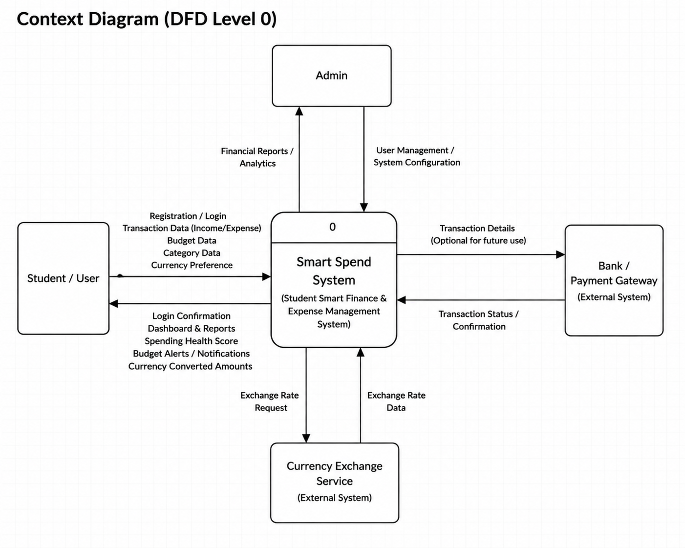

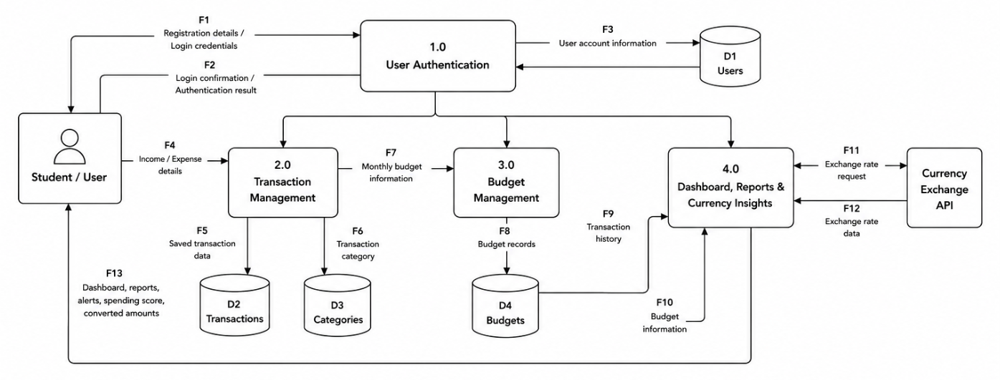

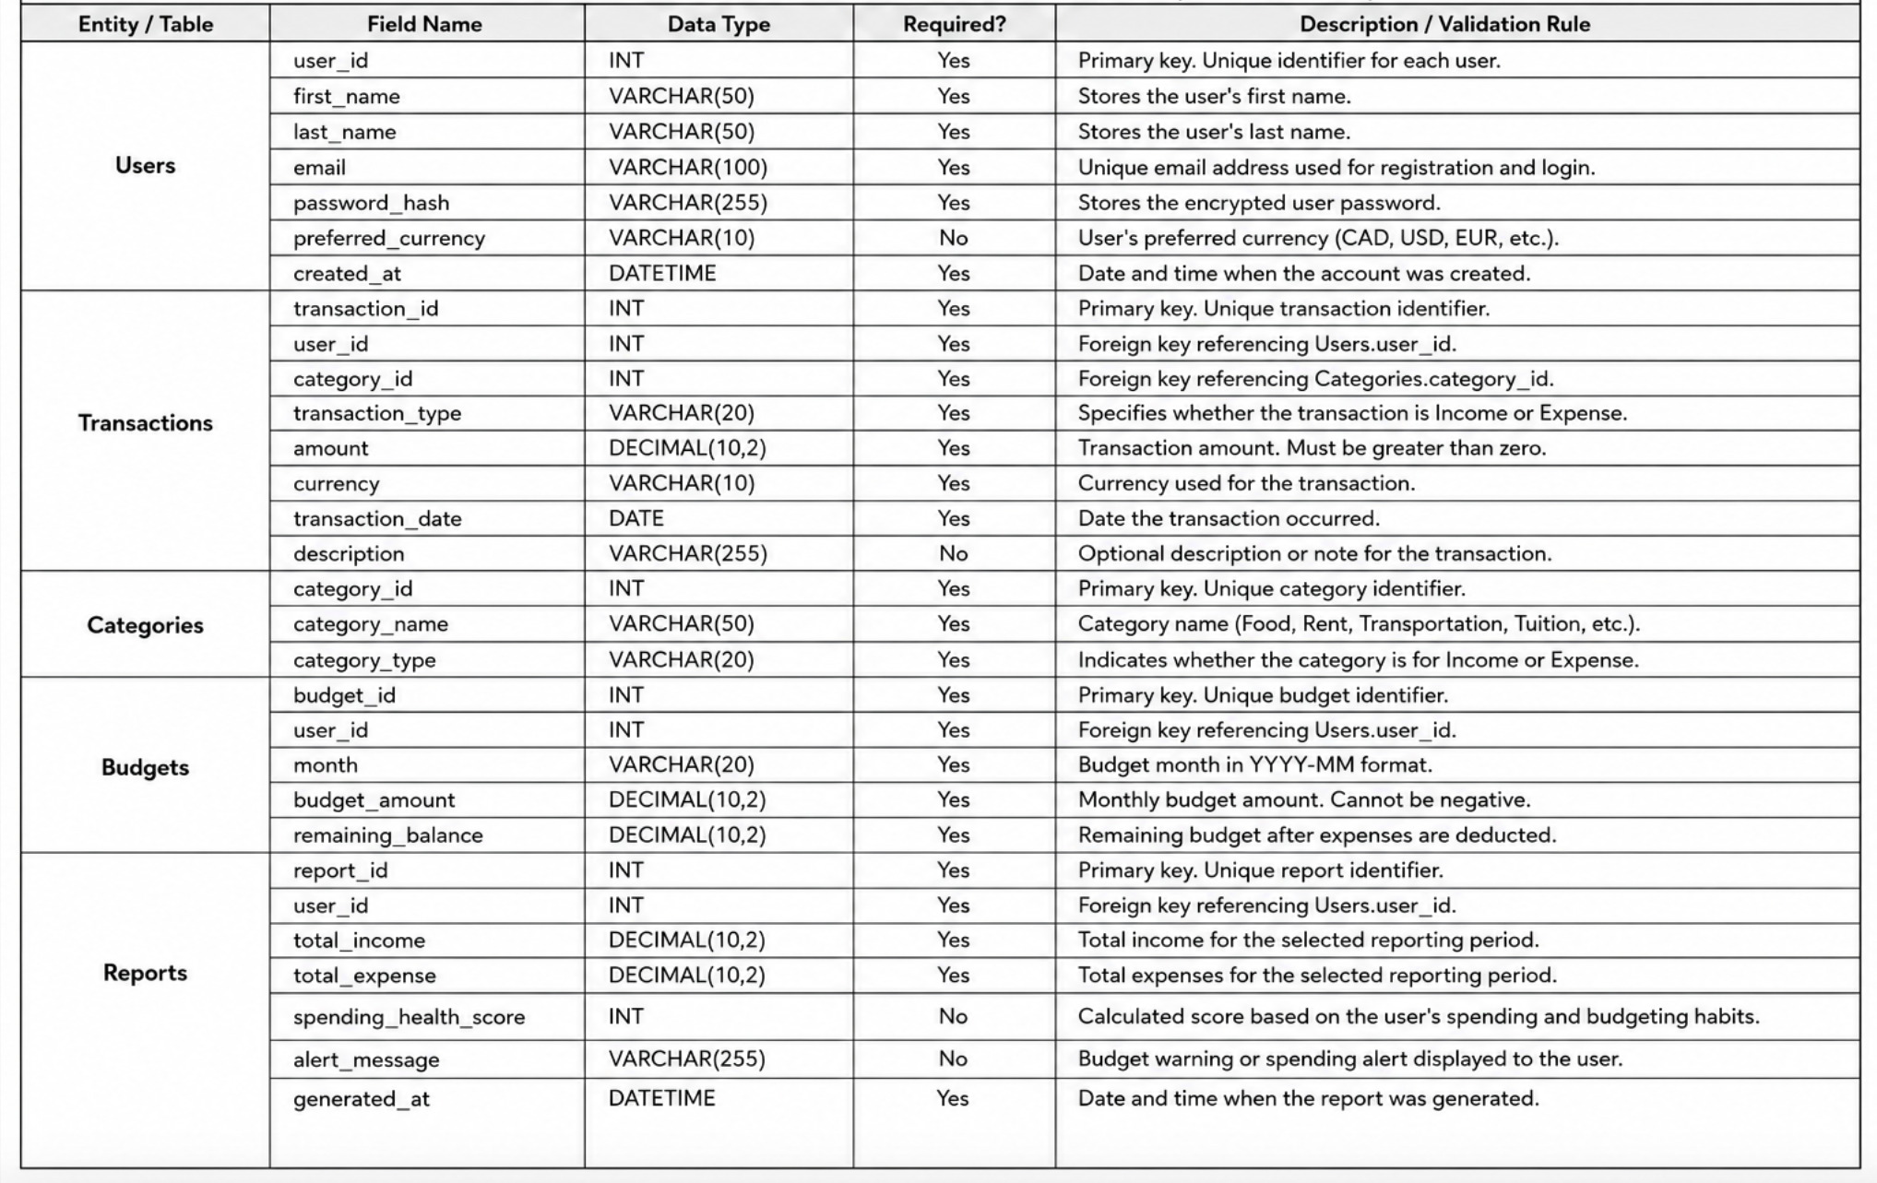

3.5 Business Rules
List only critical business rules that affect system behavior, validation, workflow, or decision logic.
Add or remove rows as needed. The number of rows in this template is not a required limit.
Business Rule ID | Description | Related Scenario / User Story | Related UI / System Area
BR-01 | Every user must register with a unique email address. | US-01 / SC-01 | Registration
BR-02 | Users must be logged in before accessing financial information. | US-02 / SC-01 | Authentication
BR-03 | Transaction amount must be greater than zero. | US-03, US-04 / SC-02 | Transaction Form
BR-04 | Every transaction must belong to exactly one category. | US-05 / SC-02 | Transaction Management
BR-05 | Budget amount cannot be negative. | US-06 / SC-03 | Budget Management
BR-06 | Spending Health Score is calculated only when sufficient transaction history exists. | US-09 / SC-06 | Dashboard

3.6 Refined User Stories and Use Case Scenarios
Use this section to refine the most important stories and describe key end-to-end user interactions.
Scenario ID | Actor / Persona | Trigger | Main Flow | Alternative / Exception Flow
SC-01 | Student | User wants to create an account and access the system | Open registration page → Enter personal details → Submit registration form → Create account → Log in → Access dashboard | Email already registered → System displays error message and requests a different email. Invalid login credentials → Access denied and user prompted to retry.
SC-02 | Student | User wants to record income or expenses | Log in → Open Transactions page → Select Income or Expense → Enter transaction details → Select category → Save transaction → Transaction appears in history | Required fields missing → System prompts user to complete fields. Invalid amount entered → System displays validation error.
SC-03 | Student | User wants to create and manage a monthly budget | Log in → Open Budget Management page → Enter monthly budget amount → Save budget → System displays budget summary and remaining balance | Budget amount is invalid or empty → System displays validation message and prevents submission.
SC-04 | Student | User wants to view spending insights and reports | Log in → Open Dashboard → View charts, reports, spending categories, and budget performance → Analyze financial trends | No transaction data available → System displays message requesting user to add transactions before generating reports.
SC-05 | International Student | User wants to monitor expenses in multiple currencies | Log in → Add transaction → Select preferred currency → System converts and displays values in selected currency → User compares spending patterns | Currency conversion data unavailable → System notifies user and displays stored transaction values only.
SC-06 | Student | User wants to view their Spending Health Score | Log in → Open Dashboard → System analyzes transaction history and budget usage → Generate Spending Health Score → Display score with recommendations | Insufficient transaction history → System informs user that additional data is required to calculate the score.

3.7 Scenario Flows & UI Mapping
Map user stories and scenarios to UI screens or prototype flows. This replaces the previous activity diagram requirement.
Add or remove rows as needed. The number of rows in this template is not a required limit.
Scenario ID | Related User Story | UI Screen / Mockup Reference | Flow Notes
SC-01 | US-01 | UI-01 Registration / Login | User creates an account and signs in.
SC-02 | US-03, US-04 | UI-02 Transactions | User adds income or expense and saves it.
SC-03 | US-06 | UI-03 Budget | User creates monthly budget and views remaining balance.
SC-04 | US-07 | UI-04 Dashboard | User views reports and charts.
SC-05 | US-08 | UI-05 Currency Converter | User selects preferred currency and views converted values.
SC-06 | US-09, US-10 | UI-06 Spending Health Score | User views score and personalized recommendations.

4. Sprint 3 Design Artifacts

4.1 UI/UX Design & Prototype
Develop a scenario-driven prototype based on personas, user stories, and use case scenarios. The prototype should demonstrate end-to-end flows rather than isolated screens.
Add or remove rows as needed. The number of rows in this template is not a required limit.
Prototype Area | Related Scenario / User Story | Screen / Flow Reference | Notes
Booking Flow | US-01 / SC-01 | UI-01 to UI-04 | Shows search, booking, confirmation, and dashboard update.

4.2 Domain Model
Insert the Domain Class Diagram and briefly explain the major classes/entities and relationships.
Add or remove rows as needed. The number of rows in this template is not a required limit.
Class / Entity | Key Attributes | Relationships | Notes
Booking | bookingId, bookingDate, status | Student creates Booking; Booking reserves Equipment | Core entity for reservation flow

5. Data Design (Sprint 3)
Choose the database design approach that best fits the system. If both RDBMS and NoSQL are used, complete both relevant subsections.

5.1 RDBMS Design: ERD
Insert the Entity Relationship Diagram (ERD) and explain the major entities and relationships.
Add or remove rows as needed. The number of rows in this template is not a required limit.
Entity | Primary Key | Relationships | Notes
Booking | booking_id | Many bookings belong to one user; one booking reserves one equipment item. | Supports the main booking scenario.

5.2 RDBMS Design: Data Dictionary
Complete this table for the key entities and fields shown in the ERD.
Add or remove rows as needed. The number of rows in this template is not a required limit.
Entity / Table | Field Name | Data Type | Required? | Description / Validation Rule
Booking | booking_id | INT | Yes | Unique identifier for each booking record.

5.3 NoSQL Design Option
Use this section if the solution uses NoSQL. Define data models and provide corresponding sample documents.
Add or remove rows as needed. The number of rows in this template is not a required limit.
Collection / Document Type | Purpose | Key Fields | Sample Document / Structure Notes
bookings | Stores booking requests and statuses | bookingId, userId, equipmentId, status | { bookingId: "B001", userId: "U001", status: "confirmed" }
Important: Database design must support at least one complete end-to-end user scenario demonstrated in the prototype.

6. Agile Planning Overview (Sprint 4)
This section captures the system’s readiness for implementation in PRJ666. It focuses on environment setup, repository structure, and the initial vertical slice required to begin development.

6.1 System Setup & Environment Readiness
Add or remove rows as needed. The number of rows in this template is not a required limit.
Item | Description | Status / Notes
Development Environment | Project can run locally with documented setup steps. | Ready for PRJ666 implementation.

6.2 GitHub & Project Setup
Add or remove rows as needed. The number of rows in this template is not a required limit.
Item | Description | Status / Notes
GitHub Repository | Repository created with README, project structure, and initial setup instructions. | Ready / link included by team.

6.3 Vertical Slice Planning
A vertical slice represents one complete end-to-end feature that connects the UI, application logic, and data layers. In PRJ566, the vertical slice is designed, validated, and demonstrated conceptually, ensuring readiness for PRJ666 implementation.
Add or remove rows as needed. The number of rows in this template is not a required limit.
Feature | UI Component(s) | Application Logic / Service | Data Layer | Status / Notes
Booking Flow | Booking form and confirmation screen | Validate availability and create booking request | Booking table/document | Developed in PRJ566 and validated for PRJ666 readiness.

7. Product Backlog & Sprint Readiness (Sprint 4)

7.1 Product Backlog
The general product backlog includes high-level user stories with clear descriptions only. Detailed grooming can continue in PRJ666.
Add or remove rows as needed. The number of rows in this template is not a required limit.
User Story ID | Description | Priority | Status / Notes
US-05 | As an admin, I want to view all bookings so that I can manage facility usage. | Medium | Future backlog item; not fully groomed yet.

7.2 Sprint 1 Candidates
Only Sprint 1 candidate stories must be fully groomed before PRJ666 Sprint 1 planning.
Add or remove rows as needed. The number of rows in this template is not a required limit.
User Story ID | Description | Acceptance Criteria | Testing Scenarios | Notes
US-01 | As a student, I want to book equipment so that I can reserve it in advance. | Given available equipment, when the user selects a valid time and confirms, then the booking is saved and confirmation is shown. | Test successful booking; test unavailable time; test missing required fields. | Candidate for PRJ666 Sprint 1.

8. Client / Faculty Sign-off
Use this section to confirm final review, scope approval, and readiness for PRJ666 implementation.
Add or remove rows as needed. The number of rows in this template is not a required limit.
Name | Role | Approval / Comments | Date | Signature
Faculty Reviewer | Instructor | Approved for PRJ666 readiness review. | YYYY-MM-DD

References:

Government of Canada. (n.d.). Financial literacy programs and resources. Retrieved June 5, 2026, from https://www.canada.ca/en/financial-consumer-agency/services/financial-literacy-programs.html
YNAB. (n.d.). You Need A Budget. Retrieved June 5, 2026, from https://www.ynab.com
PocketGuard. (n.d.). PocketGuard budgeting app. Retrieved June 5, 2026, from https://pocketguard.com

